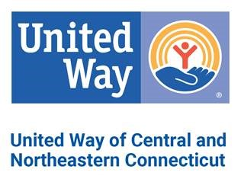
EMAIL ORDER TO: tglass-tripp@unitedwayinc.org

2018 CAMPAIGN MATERIALS ORDER FORM

Downloads are available online at unitedwayinc.org/Campaign-Marketing-Materials
Date: ________________________________ Coordinator Name: ______________________________________________
Company Name: ______________________________________________________________________________________
Street/Delivery Address: ________________________________________________________________________________
Coordinator Phone: ______________________ Coordinator Email: ___________________________________________
Are you able to pick up the materials? __________ Date/Time of pickup: _______________________________________
May we mail you these materials? ___________ Date you must receive these materials: __________________________
There is no cost for these materials. Please indicate the quantity of each item.
SOLICITATION MATERIALS EDUCATIONAL and SUPPORT MATERIALS
_______ Campaign Brochure (English) _______2-1-1 Brochure – English/Spanish
_______ Campaign Brochure (Spanish) _______2-1-1 Childcare Brochure – English/Spanish
_______ Pledge Form _______2-1-1 Child Development Info Brochure-English/Spanish
_______ Campaign Report Envelope _______2-1-1 Senior Services Brochure – English/Spanish
_______ Special Events Report Envelope _______2-1-1 Info Sheets – 8.5 x 11 – English/Spanish
_______ Campaign Video _______2-1-1 Wallet Card – English OR Spanish (circle)
_______ Coordinator Guide
_______ Posters LEADERSHIP & AFFINITY GROUPS MATERIALS
_______ Table Tent Cards _______Women United Brochure
_______ NFL Schedule _______Emerging Leaders Society Brochure
_______Leaders in Giving Brochure
_______Coordinator Tips for Leadership Giving
INCENTIVE / RECOGNITION ITEMS
_______Paper T-Shirt (great for fundraising or coloring contests)
_______UW Stickers (use for dress-down days or recognize donors)
_______Thank you cards with envelopes
_______Agency Designation Code Guide (download available online)
_______Balloons
FOR UNITED WAY BRANDED ITEMS, VISIT WWW.UNITEDWAYSTORE.COM
For internal United Way Campaign use:

Manager: ________________________________________________________________________________________________

Packed by: _______________________________________________________________________________________________
Date filled: _____________________________________________ To be delivered? ____________________________________
(Complete information at top of request form)

