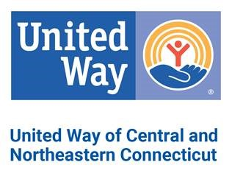
EMAIL ORDER TO: campaign2021@unitedwayinc.org

2021 COMMUNITY CAMPAIGN MATERIALS ORDER FORM

Downloads are available online at unitedwayinc.org/Campaign-Marketing-Materials
Date:_______________________________Coordinator Name: ______________________________________________
CompanyName: ______________________________________________________________________________________
Street/Delivery Address: ________________________________________________________________________________
Coordinator Phone: ______________________ Coordinator Email: ___________________________________________
Are you able to pick up the materials? __________ Date/Time of pickup: _______________________________________
May we mail you these materials? ___________ Date you must receive these materials: __________________________
There is no cost for these materials. Please indicate the quantity of each item.
SOLICITATION MATERIALS EDUCATIONAL and SUPPORT MATERIALS
_______ Campaign Brochure (English) _______2-1-1 Wallet Card – English OR Spanish (circle)
_______ Campaign Brochure (Spanish)
_______ Pledge Form (English) LEADERSHIP and AFFINITY GROUPS MATERIALS
_______ Pledge Form (Spanish) _______Women United Brochure
_______ Campaign Report Envelope _______Emerging Leaders Society Brochure
_______ Special Events Report Envelope _______Leaders in Giving Brochure
_______ Coordinator Guide
_______ Posters

INCENTIVE / RECOGNITION ITEMS
_______United Way Stickers (use for dress-down days or recognize donors)
_______Thank you cards with envelopes
_______Balloons
FOR UNITED WAY BRANDED ITEMS, VISIT WWW.UNITEDWAYSTORE.COM
For internal United Way Campaign use:

Manager: ________________________________________________________________________________________________

Packed by: _______________________________________________________________________________________________
Date filled: _____________________________________________ To be delivered? ____________________________________
(Complete information at top of request form)

