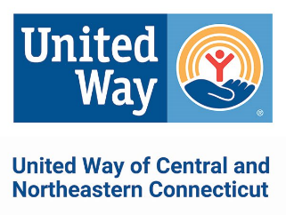
EMAIL ORDER TO: kevans@unitedwayinc.org
2023 COMMUNITY CAMPAIGN MATERIALS ORDER FORM
Downloads are available online at: unitedwayinc.org/Campaign-Marketing-Materials
Date: _______________________________ Coordinator Name: ______________________________________________
Company Name: ____________________________________________________________________________________
Street/Delivery Address: ______________________________________________________________________________
Coordinator Phone: ______________________ Coordinator Email: __________________________________________
Are you able to pick up the materials? __________ Date/Time of pickup: ______________________________________
May we mail you these materials? ___________ Date you must receive these materials: _________________________
There is no cost for these materials. Please indicate the quantity of each item.

SOLICITATION MATERIALS EDUCATIONAL and SUPPORT MATERIALS
_______ Campaign Brochure (English) _______211 Wallet Card – English OR Spanish (circle)
_______ Campaign Brochure (Spanish)
_______ Pledge Form (English) LEADERSHIP and AFFINITY GROUPS MATERIALS
_______ Pledge Form (Spanish) _______Women United Brochure
_______ Campaign Report Envelope _______Emerging Leaders Society Brochure
_______ Special Events Report Envelope _______Leadership Giving Brochures
_______ Coordinator Guide _______Women of Tocqueville Info Sheet
_______ Posters
_______ Table Tents

INCENTIVE / RECOGNITION ITEMS
_______Thank you cards with envelopes _______ Paper LIVE UNITED T-Shirts
_______Balloons
_______United Way Stickers (use for dress-down days or recognizing donors)

FOR UNITED WAY BRANDED ITEMS, VISIT WWW.UNITEDWAYSTORE.COM
